Walker, Alan William (based mainly on Environment and Conservation News 2006)
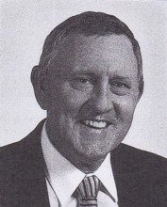
BSc Forestry ANU, graduated 1970. Assistant Divisional Forests Officer with Forests Department in 1970s. At Dwellingup in early 1970s, Collie in late 1970s, then Manjimup. Regional Leader, then Regional Manager in Southern Forests Region/Warren Region for 5 years in 1980s. Appointed Regional Manager Swan Region 31.7.1992, replacing Eric Jenkins. In Swan for 3 years. Appointed Director of Regional Services Division in 1999, responsible for 9 regions and Fire Management Services Branch. Co-authored the 1992 Draft Forest Management Plan and was state Coordinator of the Regional Forest Agreement process 1996-99. Director of Regional Services in DEC in 2006. In 2008, took up a part-time role, working on Divisional and Departmental projects.

